# EXPERIMENT - 1

**Consider the following database of All electronics; create a materialized view of 3-dimension cube of sales data according to the dimensions time, item and location. The measure displayed in qty.**

**DATABASES:**

**Customer**

|  |  |  |  |  |  |  |
| --- | --- | --- | --- | --- | --- | --- |
| **CUST_ID** | **NAME** | **ADDRESS** | **AGE** | **INCOME** | **CREDIT_INFO** | **CATEGORY** |
| c6 | zeenath | ongole | 40 | 10000 | 1 | 2 |
| c8 | smith | delhi | 23 | 20000 | 1 | 3 |
| c1 | smith | mumbai | 23 | 20000 | 1 | 3 |
| c5 | ayesha | patna | 23 | 18000 | 1 | 1 |
| c2 | sandy | lucknow | 30 | 30000 | 2 | 2 |
| c3 | john | pune | 40 | 15000 | 1 | 1 |
| c4 | shahina | hyderabad | 21 | 20000 | 2 | 3 |
| c7 | rahiman | kanigiri | 50 | 20000 | 1 | 2 |

**Item**

|  |  |  |  |  |  |  |  |  |
| --- | --- | --- | --- | --- | --- | --- | --- | --- |
| **ITEM_ID** | **NAME** | **BRAND** | **CATEGORY** | **TYPE** | **PRICE** | **PLACE_ MADE** | **SUPPLIER** | **COST** |
| i2 | washing machine | sony | semi automatic | washing machine | 6500 | USA | sony | 6000 |
| i18 | laptop | DELL | laptop | computer | 30000 | USA | DELL | 25000 |
| i5 | mobile | nokia | mobile | mobile | 9000 | uk | nokia | 8700 |
| i13 | hi-res-tv | toshiba | high resolution | tv | 15000 | japan | nikox | 13000 |
| i1 | washing machine | sony | fully automatic | washing machine | 7000 | USA | sony | 6890 |
| i3 | refrigerat or | whirpool | high cool | refrigerator | 8000 | india | whirpool | 7500 |
| i4 | lcd-tv | sony | lcd monitor | tv | 40000 | USA | sony | 39000 |

**Employee**

|  |  |  |  |  |  |
| --- | --- | --- | --- | --- | --- |
| **EMPL_ID** | **NAME** | **CATEGORY** | **GROUP_NAME** | **SALARY** | **COMMISSION** |
| e22 | reahan | home needs | engineer | 20000 | 2 |
| e21 | abhi | home needs | manager | 30000 | 1 |
| e31 | puja | web developer | engineer | 15000 | 2 |
| e32 | puja | embedded system | engineer | 25000 | 2 |
| e11 | jones | home entertainment | manager | 20000 | 2 |
| e13 | sunni | home entertainment | sales man | 7000 | - |
| e12 | netu | home entertainment | sales man | 7000 | 2 |

**Purchases**

|  |  |  |  |  |  |
| --- | --- | --- | --- | --- | --- |
| **TRANS_ID** | **CUST_ID** | **EMPL_ID** | **YEAR** | **METHOD_PAID** | **AMOUNT** |
| t100 | c1 | e11 | 2007 | visa | 9000 |
| t102 | c2 | e13 | 2009 | visa | 1500 |
| t103 | c2 | e13 | 2007 | visa | 1500 |
| t107 | c6 | e13 | 2009 | visa | 30000 |
| t111 | c7 | e22 | 2009 | visa | 7000 |
| t101 | c2 | e22 | 2009 | visa | 7000 |
| t104 | c3 | e21 | 2007 | visa | 8000 |
| t106 | c1 | e21 | 2009 | visa | 8000 |
| t109 | c5 | e13 | 2008 | visa | 3000 |
| t112 | c8 | e22 | 2009 | visa | 7000 |
| t105 | c4 | e21 | 2008 | visa | 8000 |
| t108 | c3 | e13 | 2008 | visa | 30000 |
| t110 | c5 | e22 | 2008 | visa | 7000 |

**Items_sold**

**Branch**

|  |  |  |
| --- | --- | --- |
| **TRANS_ID** | **ITEM_ID** | **QTY** |
| t100 | i5 | 2 |
| t101 | i1 | 1 |
| t103 | i13 | 1 |
| t105 | i3 | 2 |
| t106 | i3 | 1 |
| t108 | i18 | 1 |
| t111 | i1 | 1 |
| t112 | i1 | 1 |
| t102 | i13 | 1 |
| t104 | i3 | 1 |
| t107 | i18 | 10 |
| t109 | i18 | 3 |
| t110 | i1 | 1 |

|  |  |  |
| --- | --- | --- |
| **BRANCH_ID** | **NAME** | **ADDRESS** |
| b1 | city square | hyderabad |
| b2 | home needs | chicago |
| b3 | big city | mumbai |
| b4 | new city | chennai |

**Works_at**

|  |  |
| --- | --- |
| **EMPL_ID** | **BRANCH_ID** |
| e12 | b3 |
| e21 | b2 |
| e31 | b3 |
| e32 | b1 |
| e11 | b1 |
| e13 | b2 |
| e22 | b1 |

**Sales data of *All Electronics* for the years 2007,2008 & 2009.**

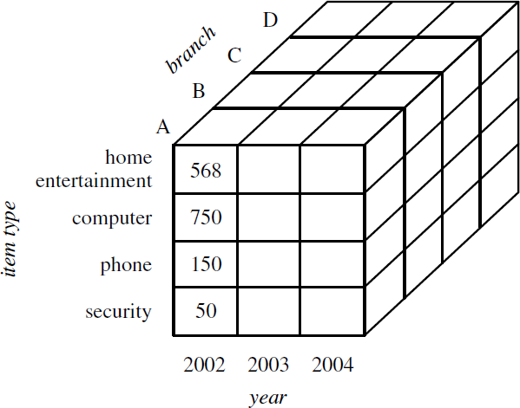

**Query:**

**Result:**

|  |  |  |  |
| --- | --- | --- | --- |
| **ADDRESS** | **YEAR** | **TYPE** | **SUM( ITEMS_SOLD. QTY)** |
| hyderabad | 2007 | mobile | 2 |
| chicago | 2007 | tv | 1 |
| chicago | 2008 | refrigerator | 2 |
| chicago | 2008 | computer | 4 |
| hyderabad | 2008 | washing machine | 1 |
| chicago | 2009 | computer | 10 |
| chicago | 2009 | refrigerator | 1 |
| chicago | 2009 | tv | 1 |
| chicago | 2007 | refrigerator | 1 |
| hyderabad | 2009 | washing machine | 3 |